**GTA Application**

## User Guide

Seth Emery, Blake Lord, Brandon Piotrowski, Ryan Borland

**Table of Contents**

User Guide 1

**Getting Started 1**

System Requirements 1

Quick Start 1

**Launching the Application 1**

**Using the Navigation Bar 2**

**Register New User/Login 3**

Registration 4

**Logging In 8**

**User Profile 10**

Viewing Account Details 10

Changing Account Info 11

**Home Page 13**

Viewing Job Listings 15

Applying to A Job Listing 16

Searching For Jobs 18

Filtering Jobs 19

**My Applications Page 20**

Viewing Applications 20

Editing an Application 21

**Administration Page 22**

Creating a New Job 22

Editing an Existing Job 23

Removing an Existing job 24

Viewing a Submitted Application 25

Opening/Closing a Submitted Application for Editing 27

Accepting an Application 28

Rejecting an Application 30

Viewing All Users 32

# 

# **Getting Started**

## **System Requirements**

Python 3

Visual Studio Code

Internet Connection

## **Quick Start**

A guide for setting up the program can also be found in the README.md file in the GitHub

1. Pull the repository
   1. git clone <https://github.com/collaboratorsje/swe-capstone.git>
2. Setup Virtual Environment

1. cd swe-capstone

2. python -m venv venv

1. Activate the virtual environment
   1. .\venv\Scripts\Activate.ps1 # If using Powershell
   2. .\venv\Scripts\activate.bat # If using Command Prompt

Note: May need to enable certain features of powershell

<https://www.makeuseof.com/enable-script-execution-policy-windows-powershell/>

1. Install Requirements

1. python -m pip install -r .\requirements.txt

1. Launch
   1. flask run

or

* 1. python main.py

1. Go to localhost:5000 in browser

# **Using the Navigation Bar**





**The Following Options are Available for Selection in the Navigation Bar:**

Home

Displays all the job listings, along with an apply button. Also includes a search bar and filters

My Applications

Displays all of the current users submitted applications, along with an edit button if the application is open for editing.

Administration (If logged in as an administrator)

Displays button for creating new jobs. Has tabs for existing jobs, submitted user applications, and users.

User Profile (If logged in, appears as first and last name)

Displays the users information and allows the user to edit their application.

Register (If not logged in)

Displays fields for users to create an account as well as fields for adding courses.

Log In (If not logged in)

Displays fields for users to log in to their account.

Log Out (If logged in)

Logs out the user and redirects to the home page.

# **Register New User/Login**

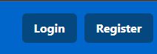

## **Registration**

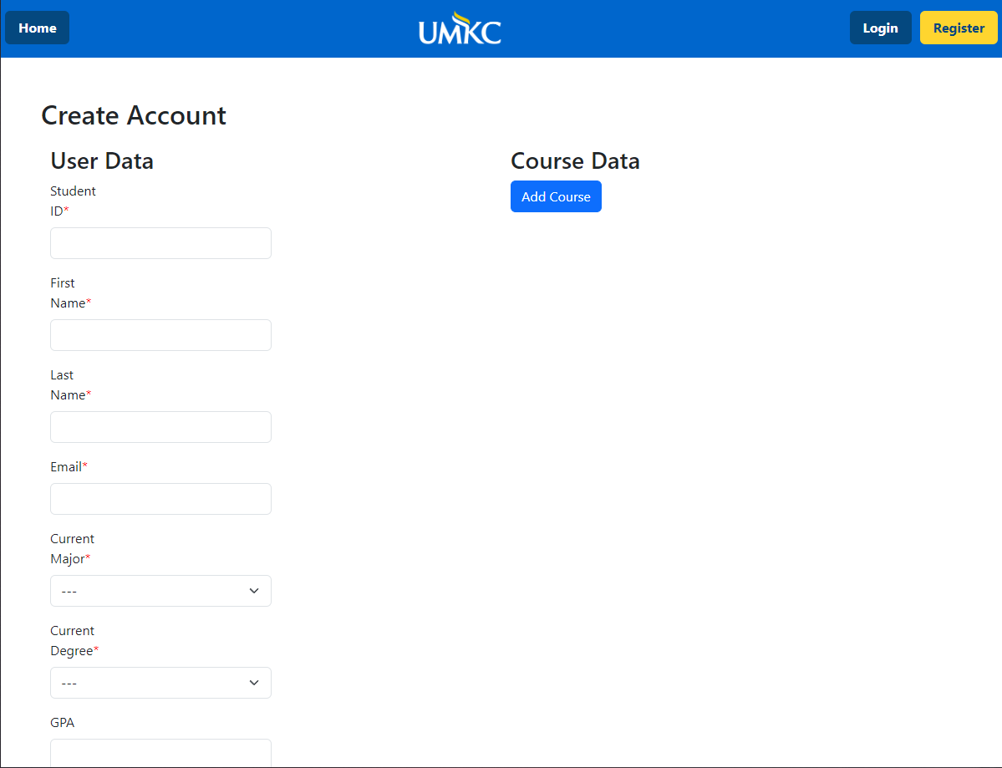

When the “Register” tab is clicked on the navigation bar the user is redirected to the create account page. From here, they can input their information into the text fields on the left side of the page.

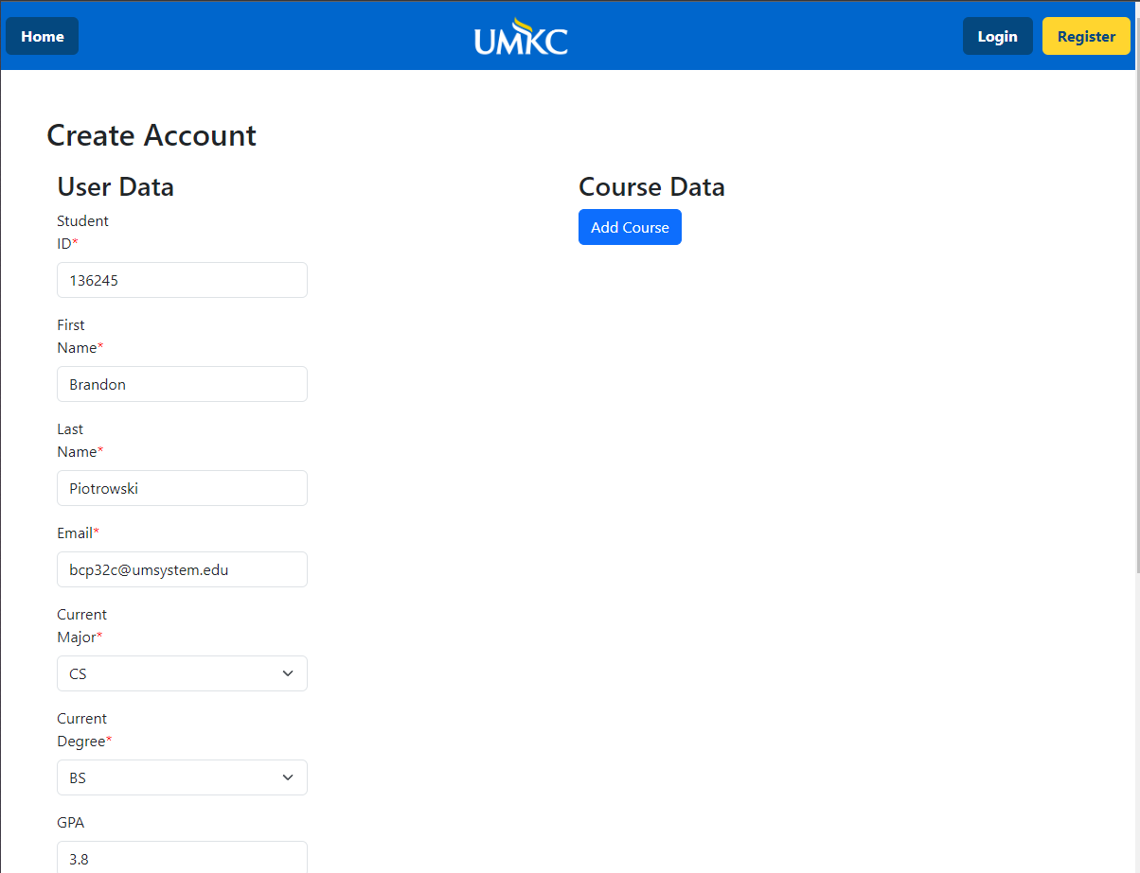

After the user has input their information they can begin to add courses by clicking on the “Add Course” button.

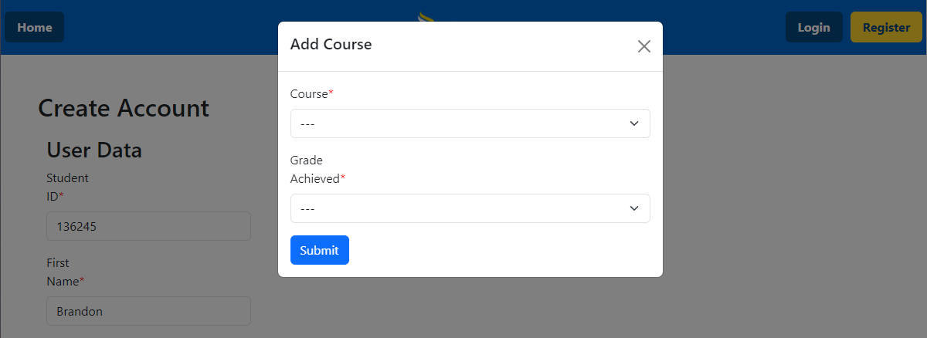

A box will appear with drop down boxes allowing for the user to add their courses taken. After clicking the submit button the courses will update and the user can continue to add courses or press the “X” to close the box.

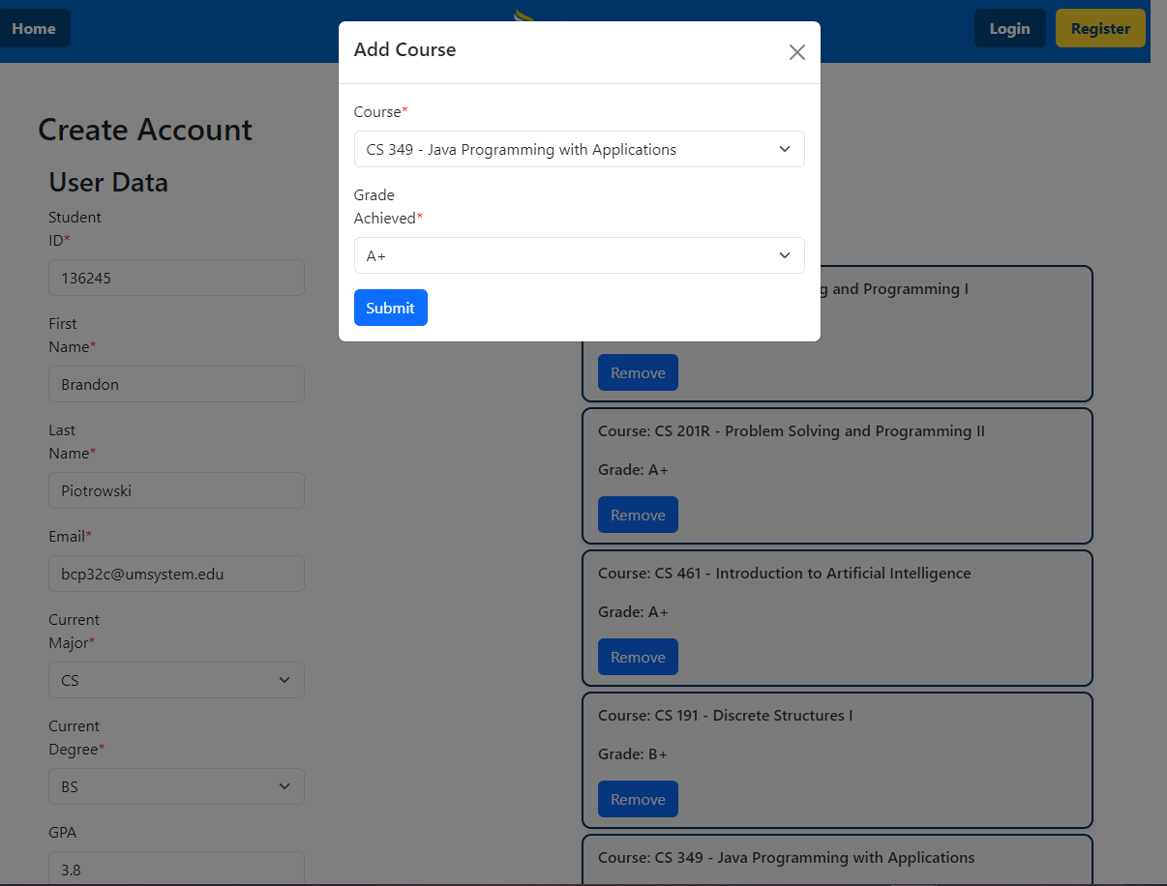

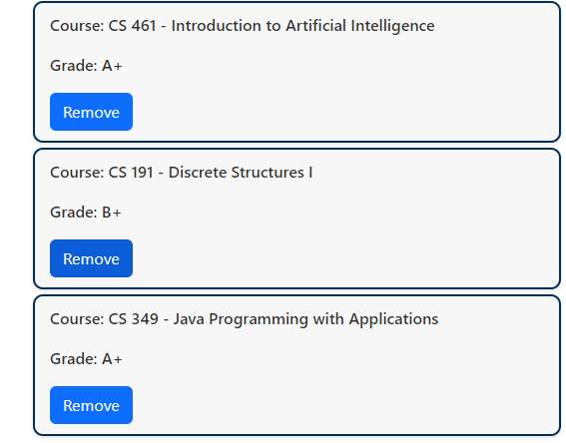

Users can also click the remove button to remove the added class in case of an error.

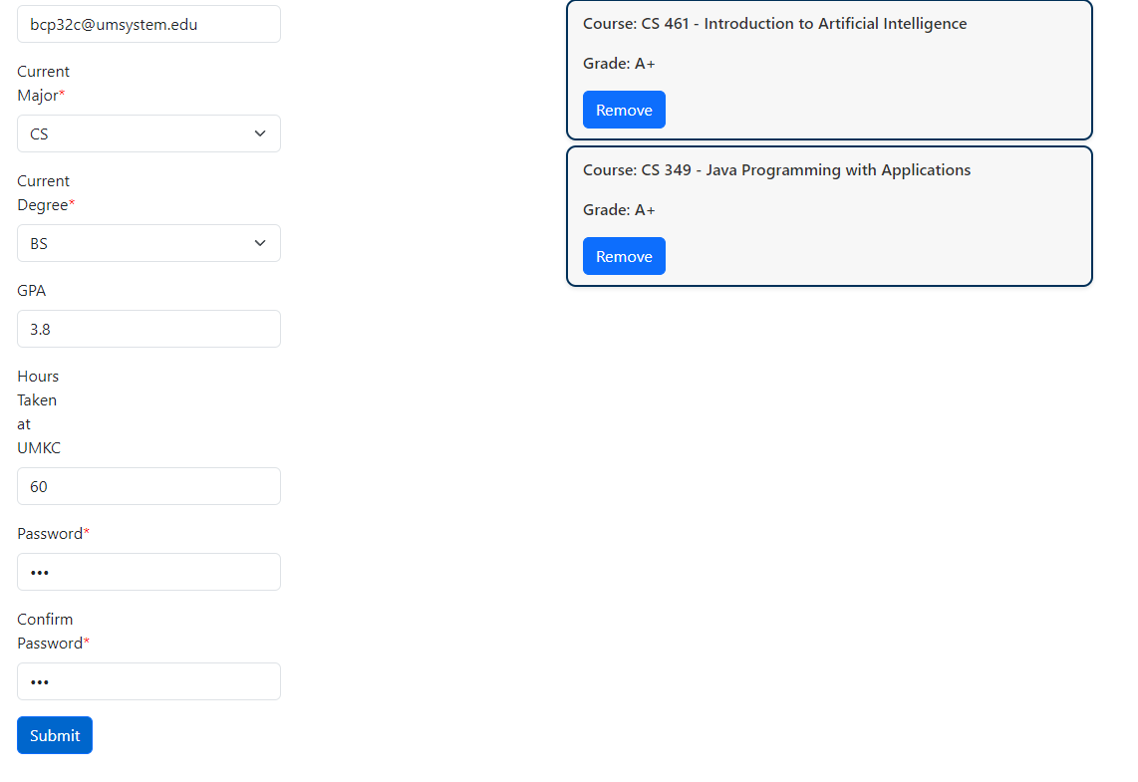

After the user has input all of their information they can click the “Submit” button to complete registration.

## **Logging In**

## 

## 

When the “Login” tab is clicked, the user will be redirected to the login page. From her the user can input the email and password associated with their account to login.

## 

## 

## 

After the user clicks the “Submit” button on the login page, if their credentials are valid they will be redirected to the home page.

## 

# **User Profile**

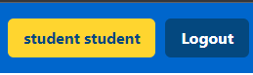

## **Viewing Account Details**

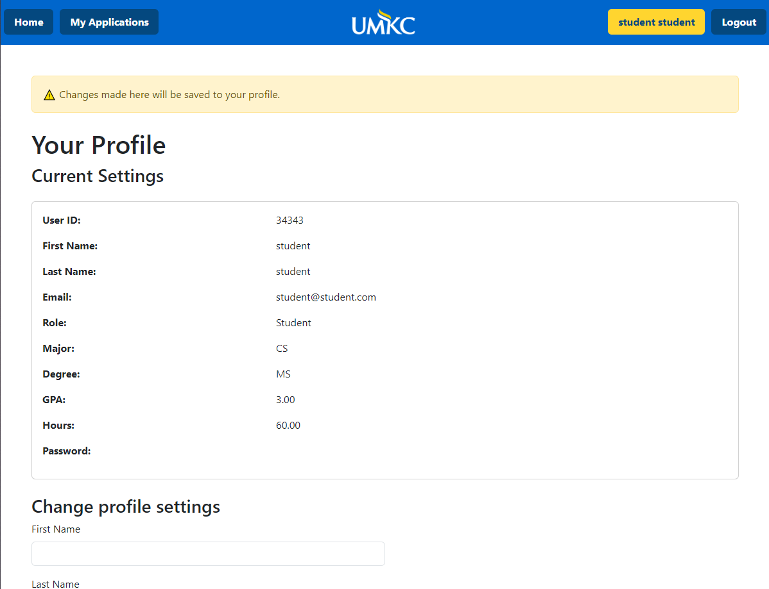

When the user clicks on their name in the navigation bar, it brings the user to the user profile page. At the top of this page all of the user's information is displayed, however, the user's password will be hidden.

## **Changing Account Info**

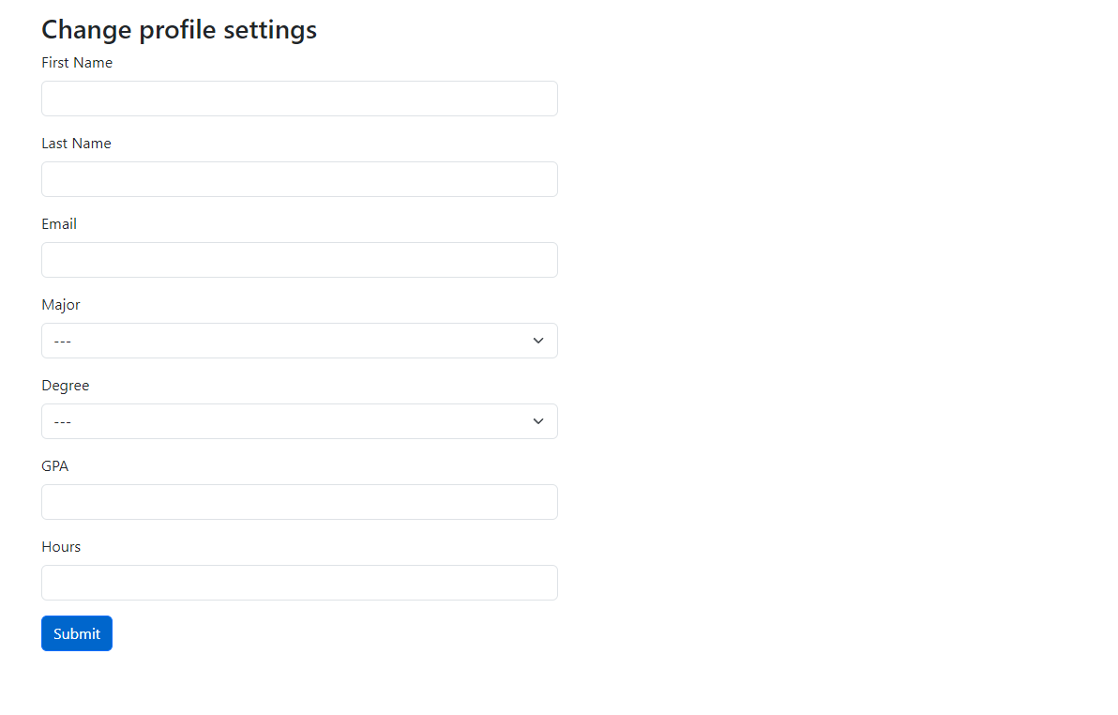

When the user scrolls down on the user profile page they will see input fields that will allow them to change their information. The user does NOT need to fill in every field to update their profile. To update their profile they only need to fill in those specific fields and click the submit button.

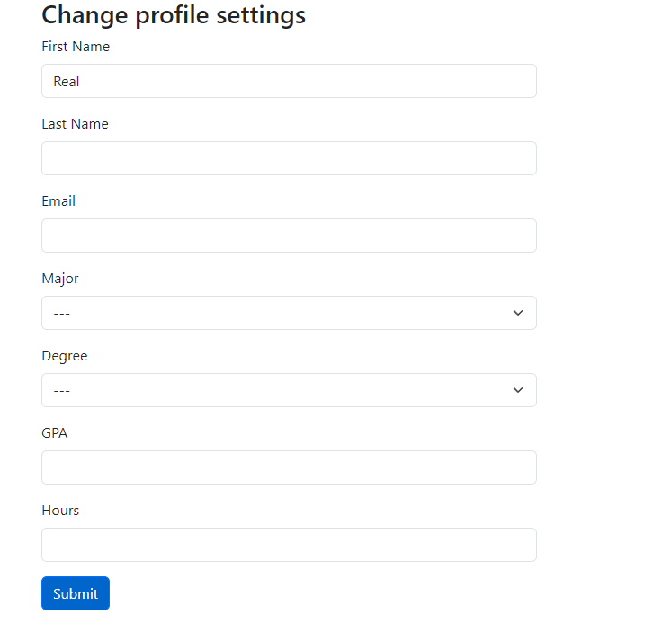

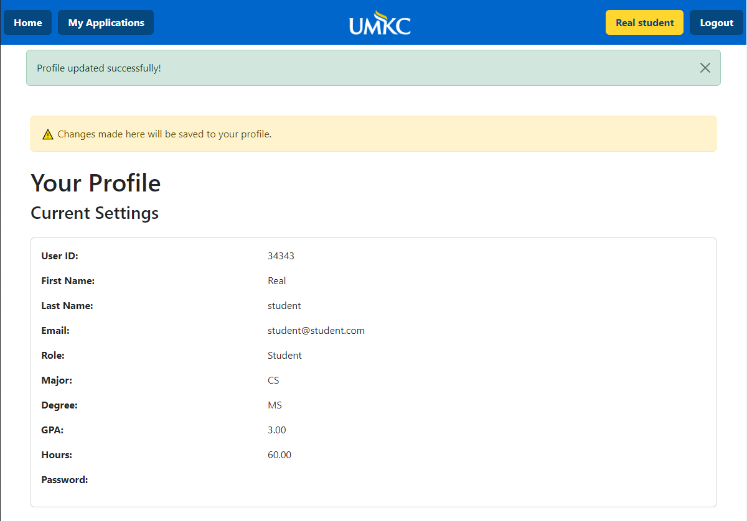

# **Home Page**

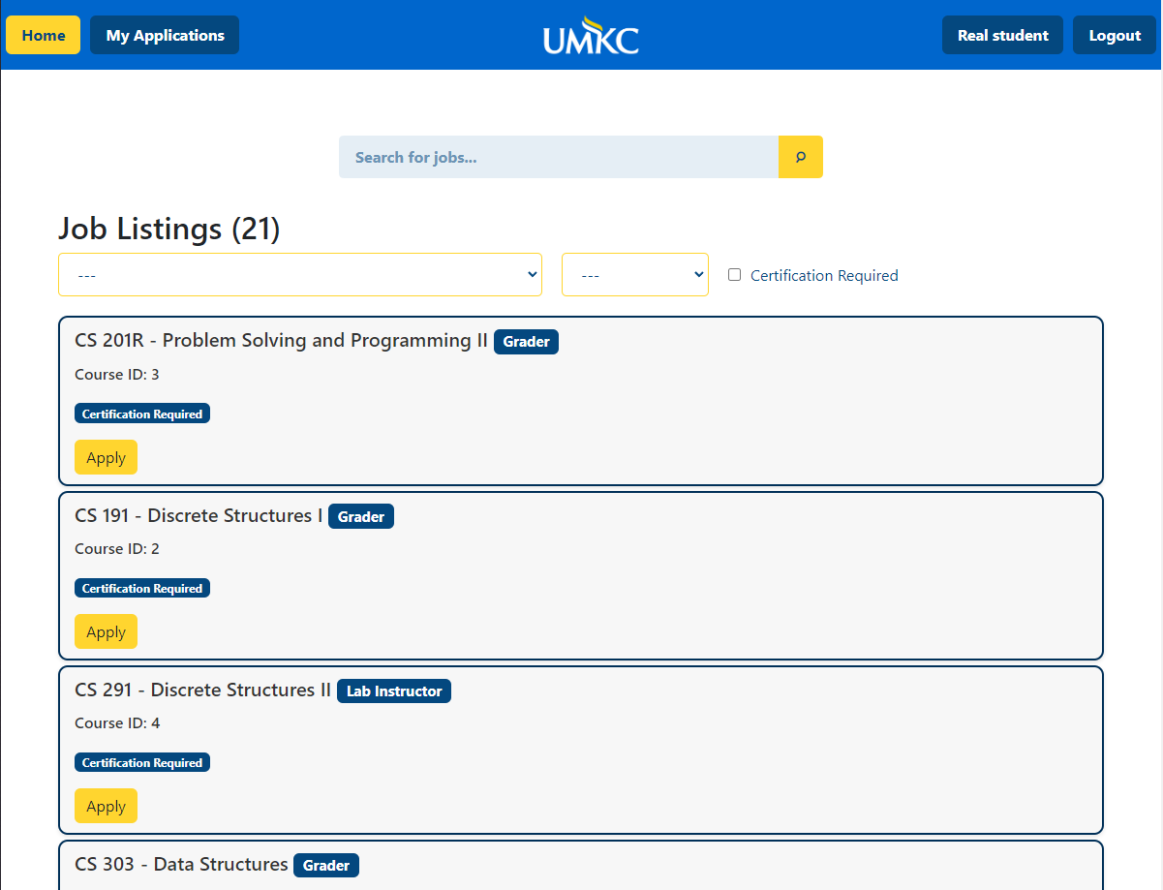

## **Viewing Job Listings**

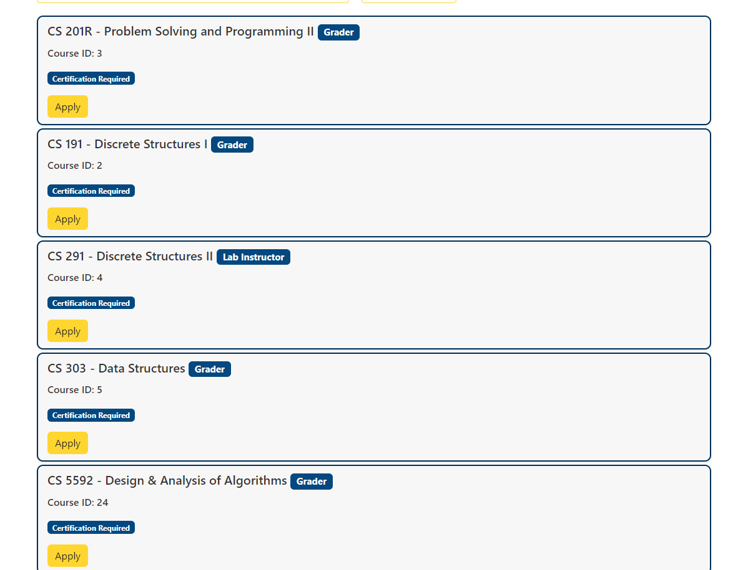

When the user clicks on the “Home” tab, they will be redirected to the Jobs Listing/Home page. All the jobs available will be listed and the user can scroll down to see them.

## **Applying to A Job Listing**

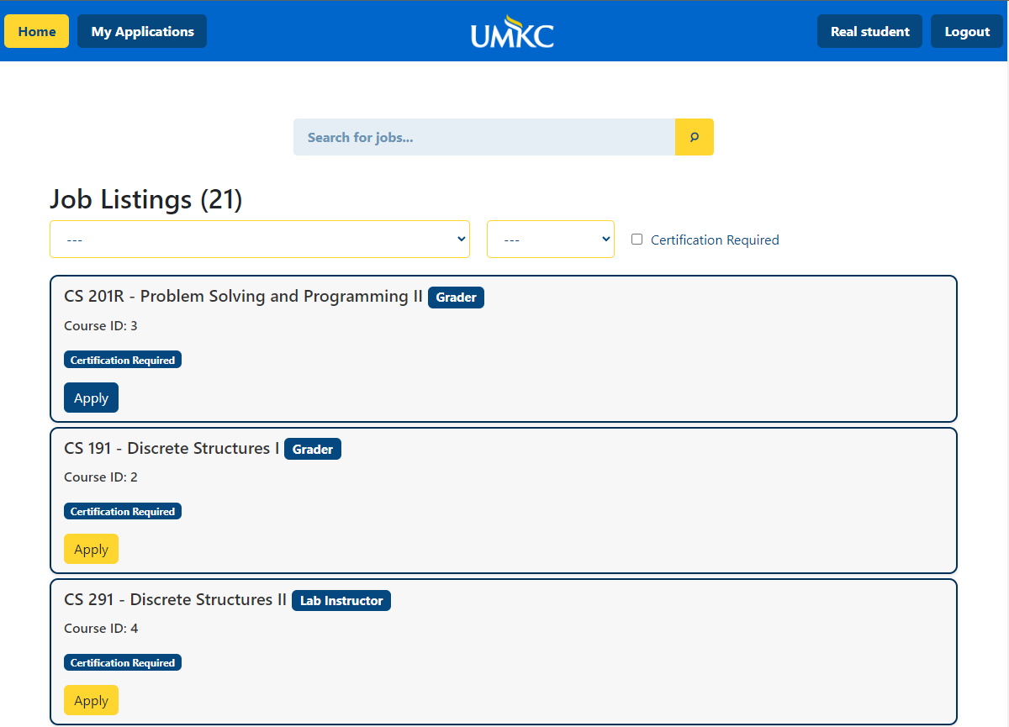

When the user finds a job they want to apply for they can click the “Apply” button. They will get redirected to the application page.

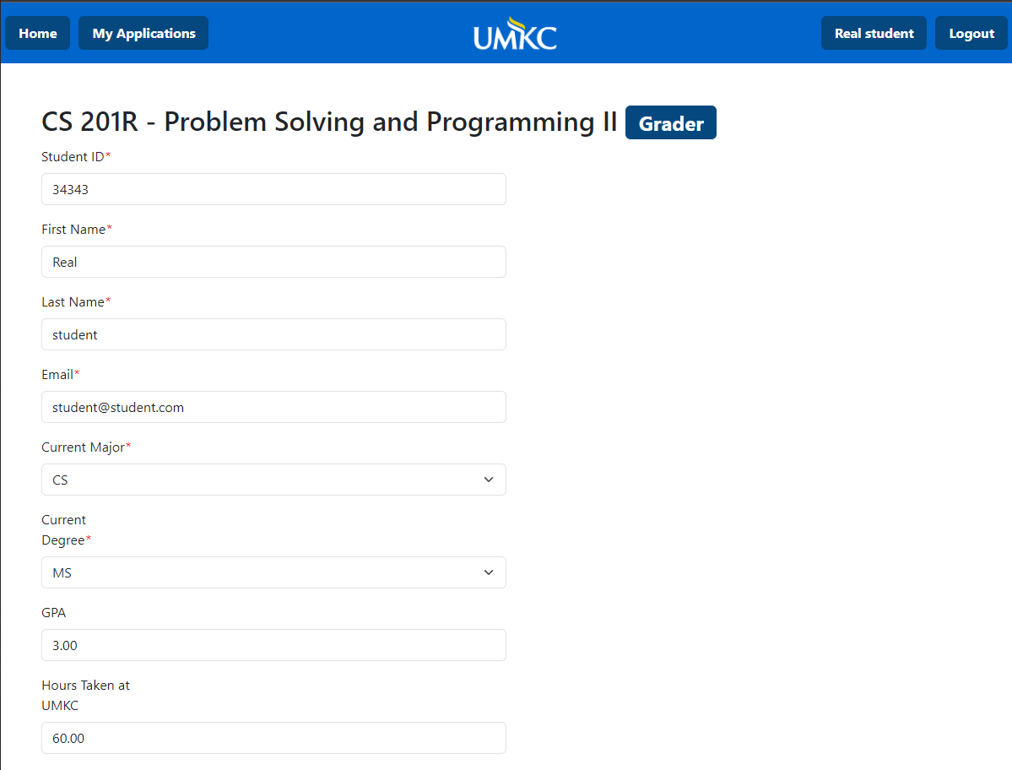

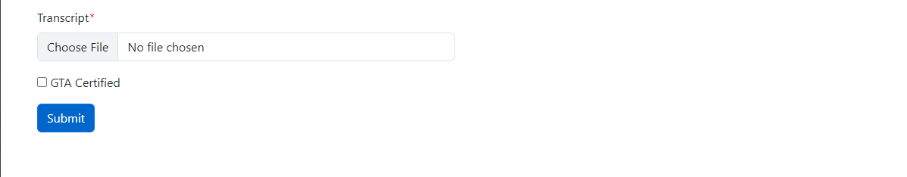

The user's application will autofill with their information. At the bottom they will be required to submit a file with their transcript. If they are gta certified, they can check the checkbox which will prompt them for another file upload to upload their gta certification.

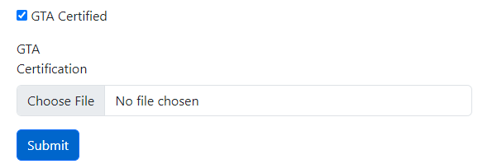

Once the user has verified their information, they can click the submit button and then will be redirected to the home page.

## **Searching For Jobs**

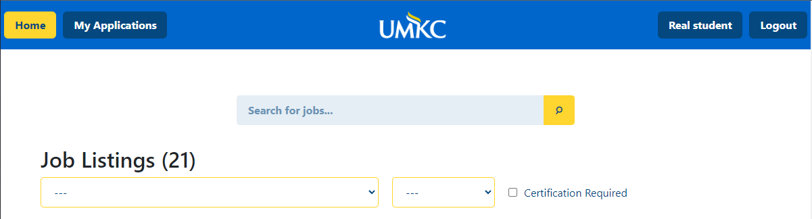

At the top of the home page there is a search bar for the user to quickly find a job.

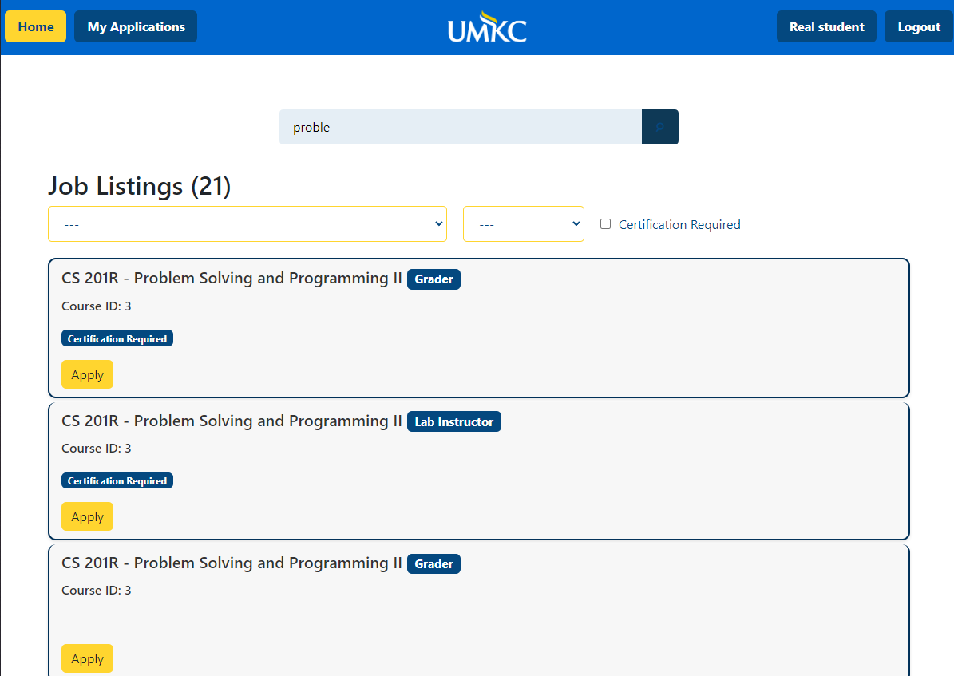

## **Filtering Jobs**

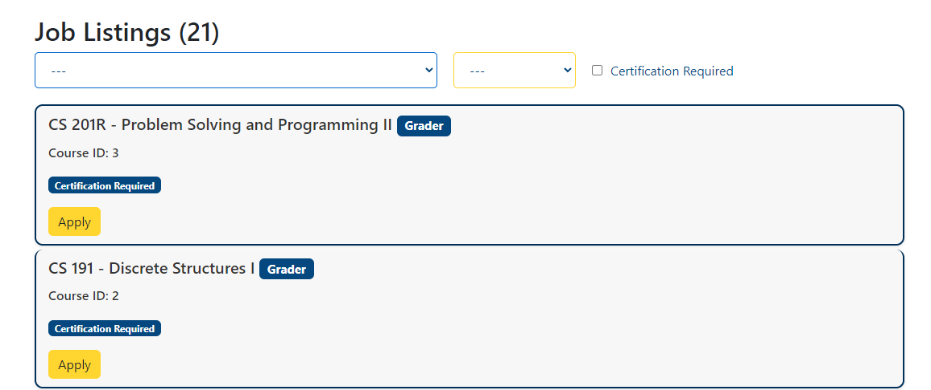

Underneath the search bar are three filtering options. The leftmost is a dropdown with all the class names, the middle dropdown is for the position type, and the right is a checkbox for certification requirements.

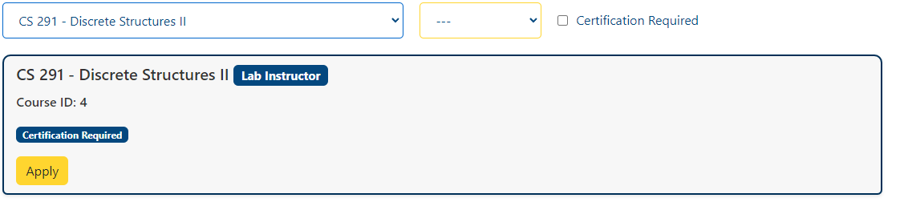

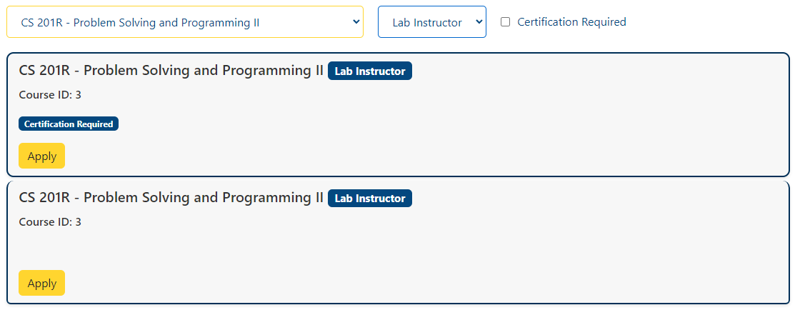

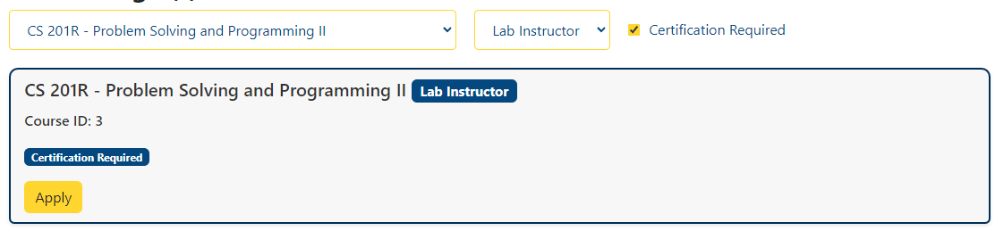

# **My Applications Page**

## **Viewing Applications**

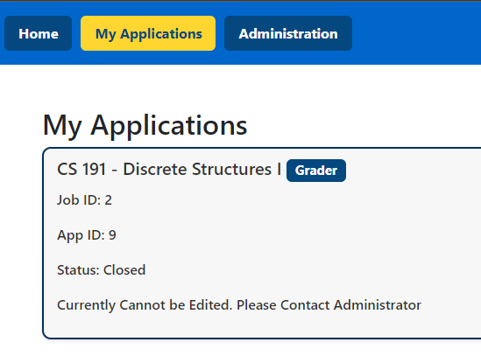

After you have submitted an application, it will appear in the “My Applications” tab. After submission it will automatically be closed for editing until an administrator opens it for you.

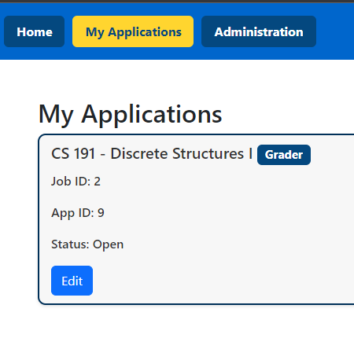

When an application is open for editing, an edit button will appear which will redirect you to the edit application page

## **Editing an Application**

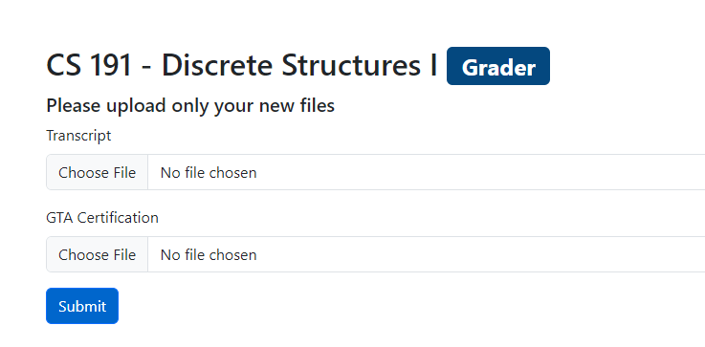

After clicking the edit button under one of your applications, you will be redirected to this page. The only entries you are allowed to edit are your file uploads. On this page you only need to submit new files. If an entry is left blank it will keep your old file.

# **Administration Page**

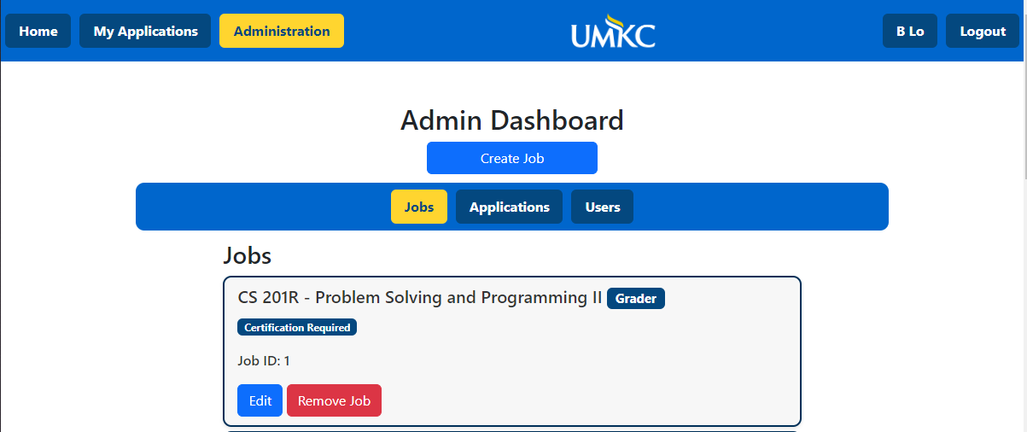

## **Creating a New Job**

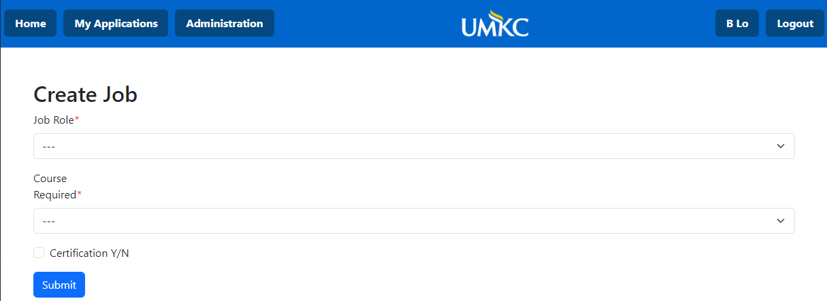

When an administrator clicks on the “Create Job” button they will be redirected to the job creation page. From here they will select the job role, course, and if certification is required. After all has been filled in they can click the “Submit” button for the job to be created.

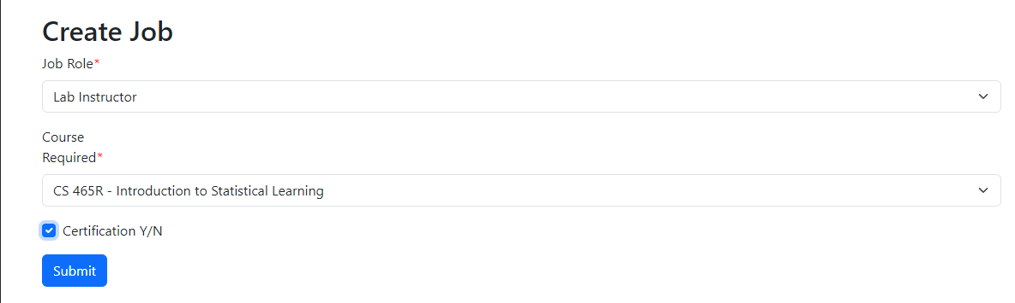

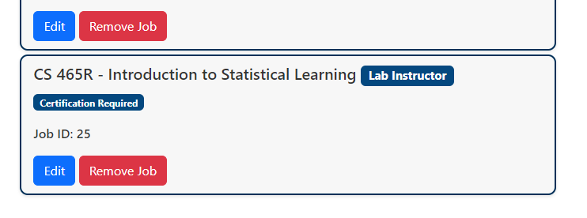

## **Editing an Existing Job**

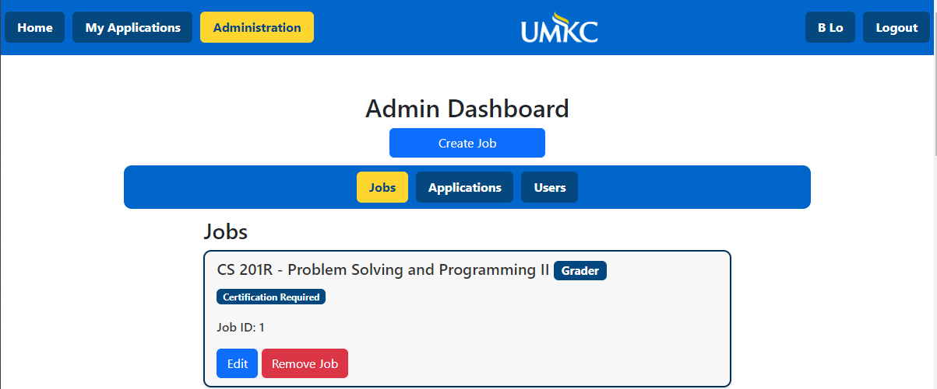

When the administrator clicks the “Edit” button for a job listing they will be redirected to the job editing page.

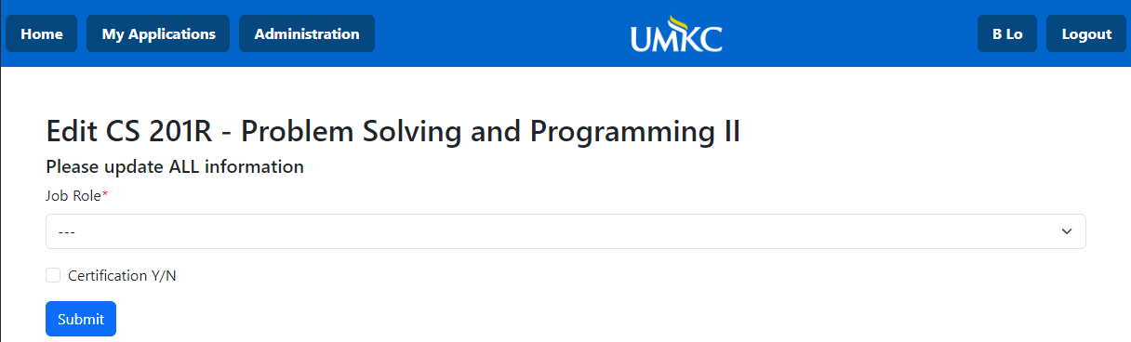

On the editing page, the administrator will be able to change the job role and the certification requirements. Then they will click the submit button to update the job.

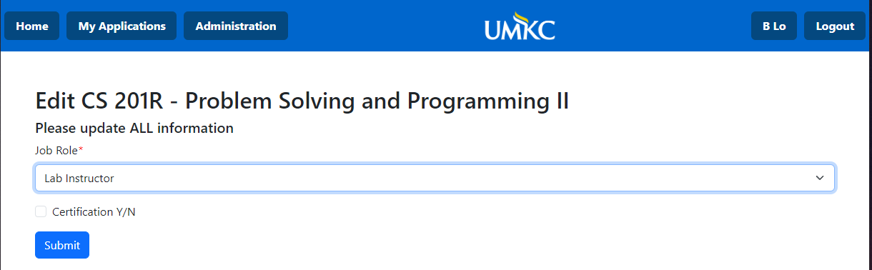

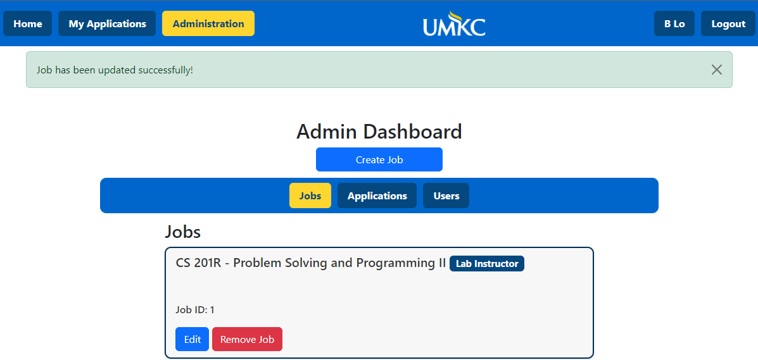

## **Removing an Existing job**

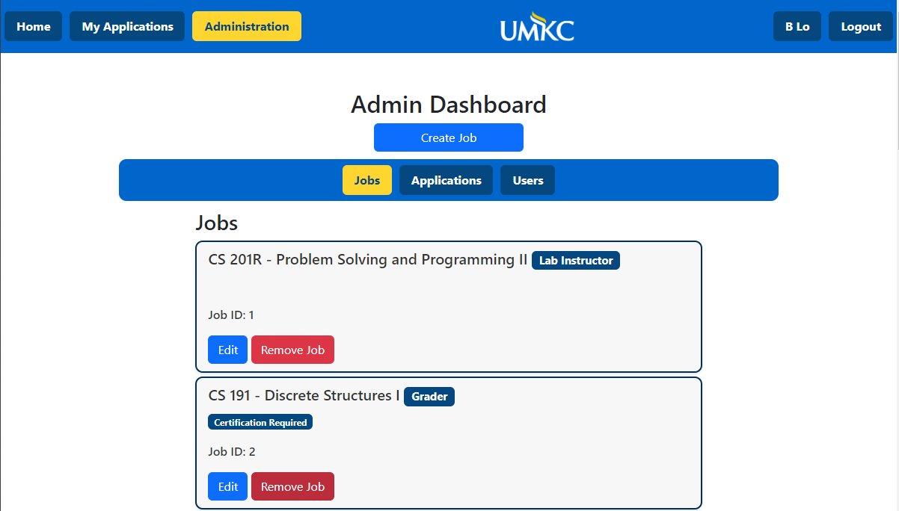

To remove a job the administrator must click the “Remove Job” button.

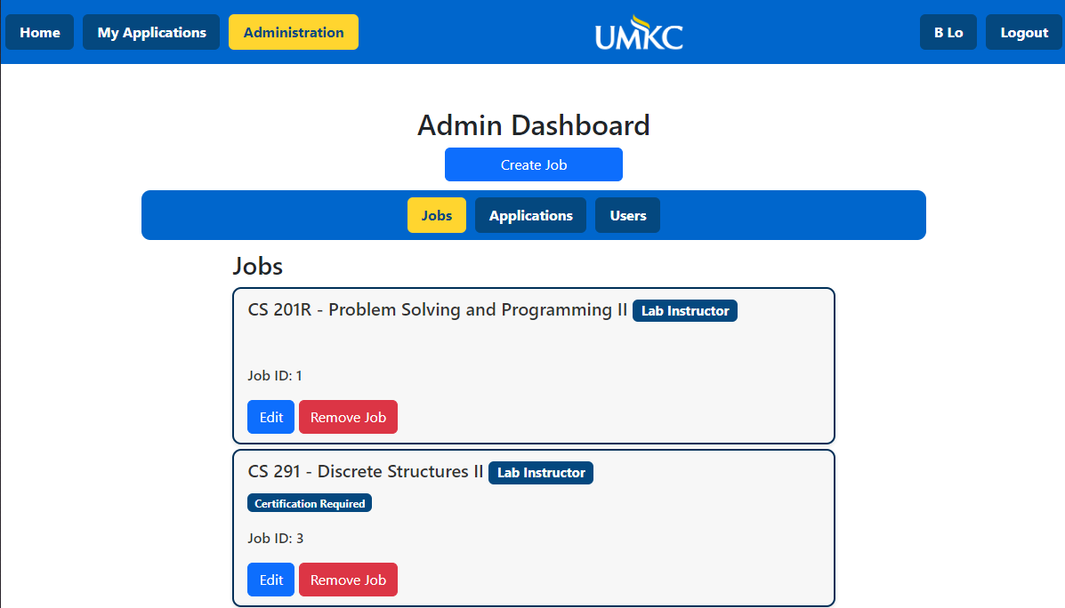

## **Viewing a Submitted Application**

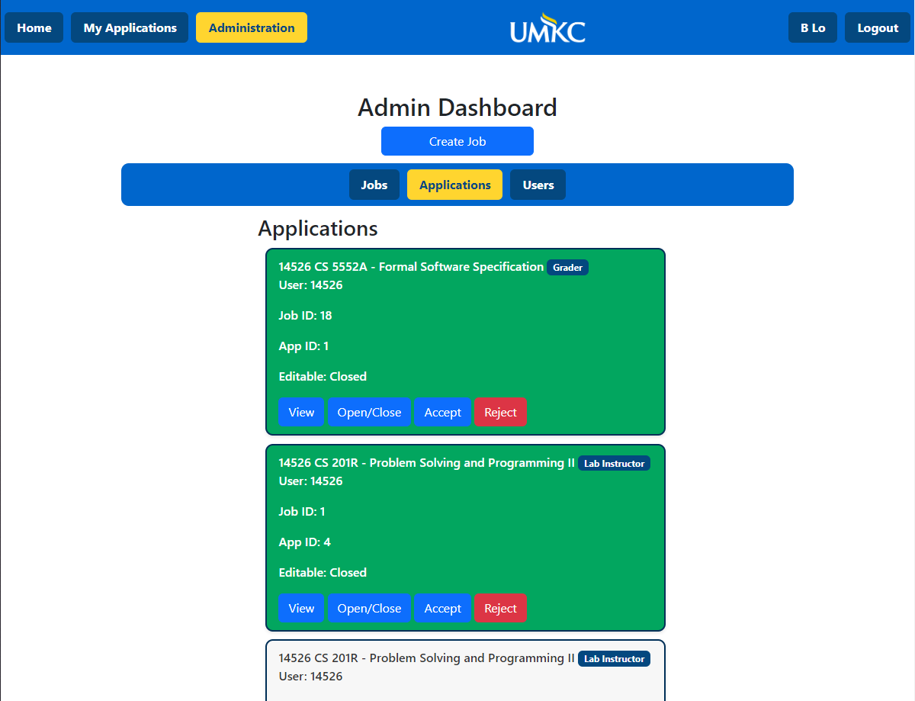

To view a user submitted application, the administrator must click the “View” button under an application listing. They will then be redirected to a new page displaying the relevant information.

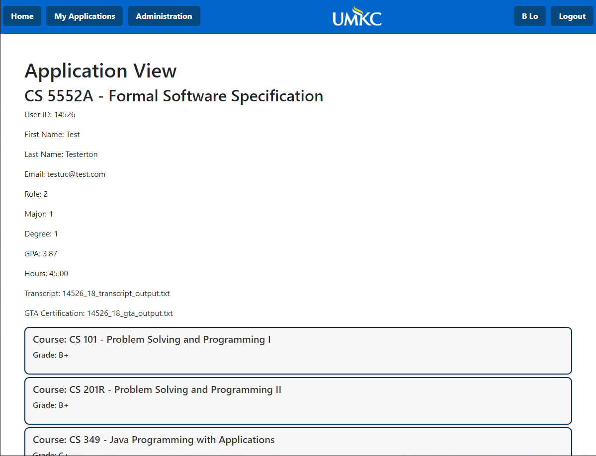

## **Opening/Closing a Submitted Application for Editing**

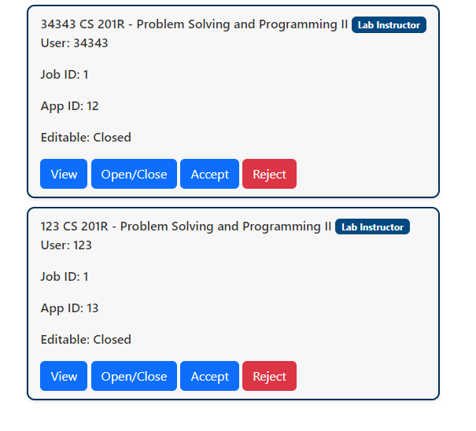

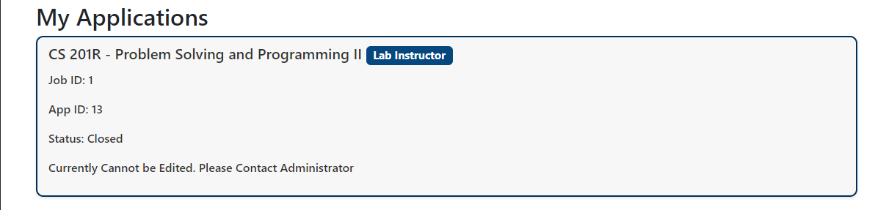

To toggle an application to be opened or closed for editing the administrator needs to click the “Open/Close” button for the corresponding application.

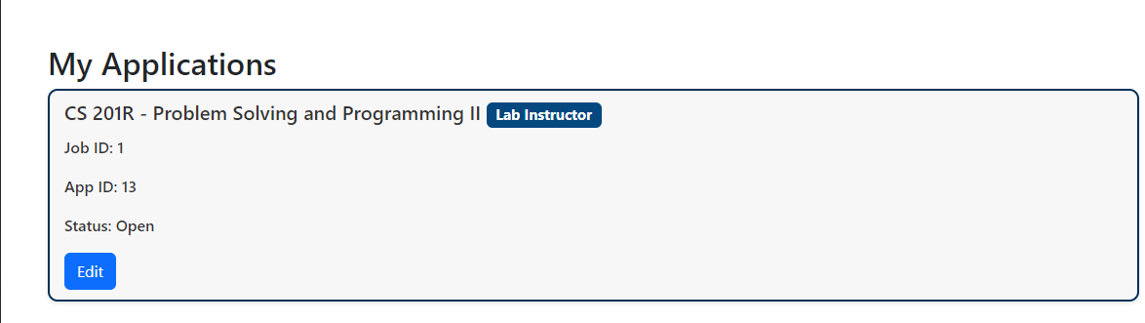

## **Accepting an Application**

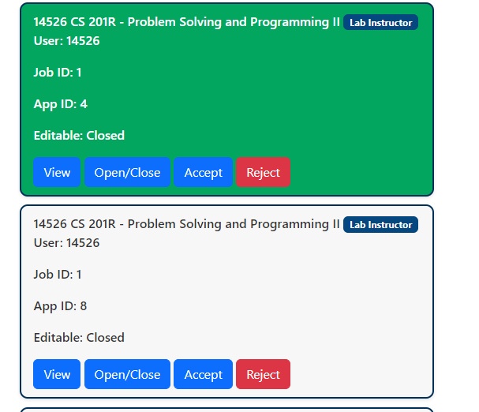

To accept an application the administrator needs to click the “Accept” button.

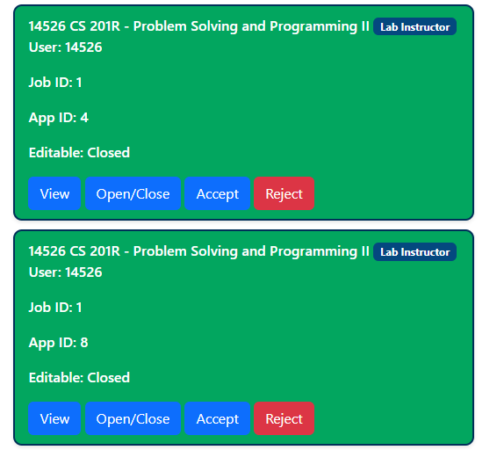

## **Rejecting an Application**

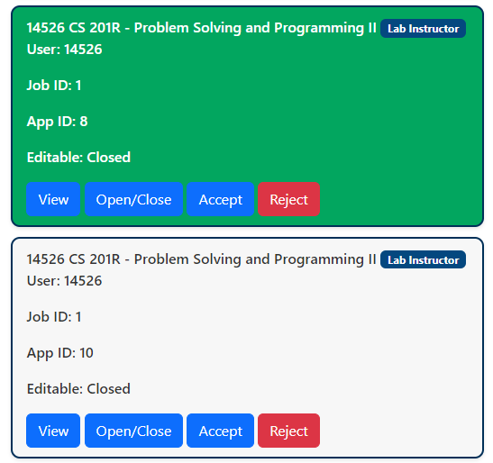

To reject an application the administrator needs to click the “reject” button.

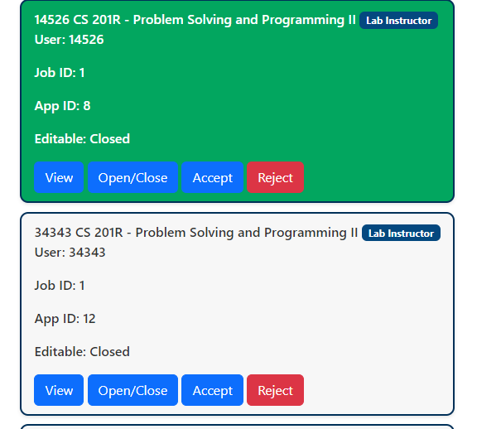

## **Viewing All Users**

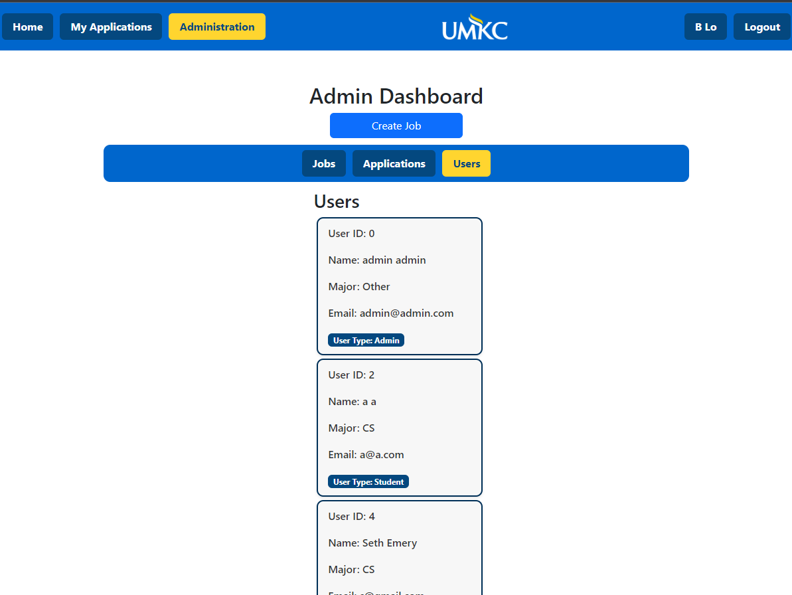

To view all users the administrator needs to click on the “Users” tab in the administration page.